Capabilities of Apple Watch for monitoring Exercise Effectiveness

Core Motion – Apple’s Framework to process accelerometer, gyroscope, pedometer, and environment-related events

SensorKit – Apple’s Framework for getting sensor data from an Apple Watch. Need to be approved research uses which are approved by apple

Core Location – Apple’s Framework for accessing and monitoring user locations

* Accelerometer – can be configured to a maximum of 100 Hz, the frequency can be adjusted to meet needs. Each data point returns an x, y and z value which is the current acceleration across the following axis:

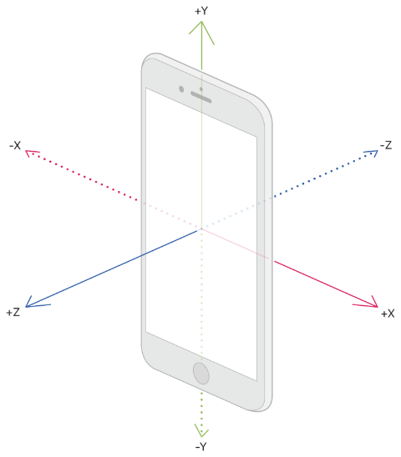

* Gyroscope – can be configured to a maximum of 100 Hz, the frequency can also be adjusted to suit needs. Each data point returns an x, y, and z value which is the current rate the device rotates around a spatial axis:

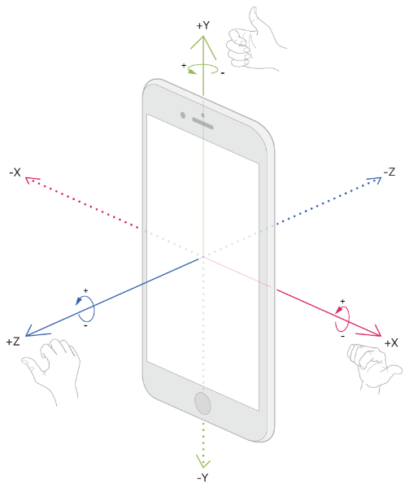

* Pedometer – can be used to retrieve step counts and other information about the distance travelled and the number of floors ascended or descended. Explicit user permission required to use the Pedometer
* Step counting
* Distance
* Floor counting
* Pace
* Cadence
* Magnetometer – Measurements of the Earth’s magnetic field relative to device. Returns 3 fields per entry. X, y, and z which all represent their respective axis magnetic field in microteslas.
* Altimeter – Altitude events report changes in both the relative and absolute altitude. Data points contain 3 field per entry. Altitude – the altitude of the device relative to sea level, measured in meters. Accuracy – the estimated uncertainty of the altimeter in meters, based on one standard deviation. Precision – the recommended resolution for the altitude, in meters
* Fall Detection – Apple watch can detect when a wearer falls, and contact emergency services if necessary. Requires explicit permission from user to use this functionality

Apple Watch Series 6/7 sensors:

* Ambient light sensor
* Accelerometer
* Gyroscope
* Heart rate sensor
* Barometric altimeter
* Compass
* Blood oxygen sensor

Note: Heart rate and blood oxygen sensors are not medical grade according to some sources so might not be 100% accurate

References:

* <https://developer.apple.com/documentation/coremotion>
* <https://developer.apple.com/documentation/corelocation>
* <https://developer.apple.com/documentation/sensorkit>
* <https://pedmore-medical.com/how-effective-is-the-new-apple-watch-at-measuring-oxygen-levels/?sfw=pass1648543899>
* <https://www.healthline.com/health-news/here-is-what-heart-health-experts-think-about-the-apple-watch-series-7>